Recommended stretches: handball
One by one + Slideshow ›Time: 11 minutes
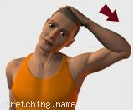 | 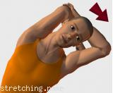 | 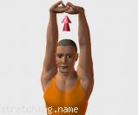 | 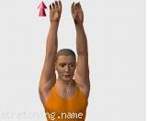
  ¹/₂₀  ref1 | 10 seconds each side
  ²/₂₀  ref2 | 10 seconds each side
  ³/₂₀  ref3 | 20 seconds
  ⁴/₂₀  ref11 | 2 times 5 seconds each one
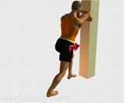 | 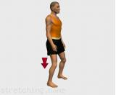 | 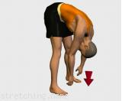 | 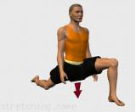
  ⁵/₂₀  ref21 | 30 seconds each leg
  ⁶/₂₀  ref4 | 30 seconds
  ⁷/₂₀  ref5 | 20 seconds
  ⁸/₂₀  ref13 | 20 seconds each leg
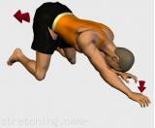 | 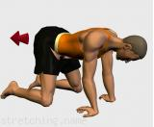 | 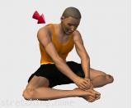 | 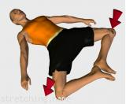
  ⁹/₂₀  ref19 | 10 seconds each arm
  ¹⁰/₂₀  ref20 | 20 seconds
  ¹¹/₂₀  ref6 | 30 seconds
  ¹²/₂₀  ref7 | 30 seconds
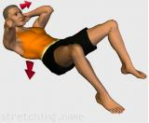 | 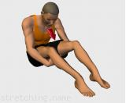 | 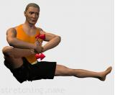 | 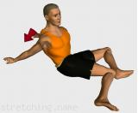
  ¹³/₂₀  ref8 | 3 times 5 seconds each one
  ¹⁴/₂₀  ref12 | 20 seconds
  ¹⁵/₂₀  ref18 | 15 times each foot clockwise and counter clockwise
  ¹⁶/₂₀  ref14 | 20 seconds each leg
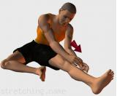 | 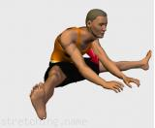 | 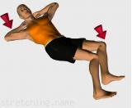 | 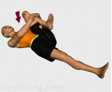
  ¹⁷/₂₀  ref15 | 20 seconds each leg
  ¹⁸/₂₀  ref16 | 30 seconds
  ¹⁹/₂₀  ref9 | 25 seconds each side
  ²⁰/₂₀  ref10 | 20 seconds each leg
Stretching routine (exercises guide) recommended for handball

