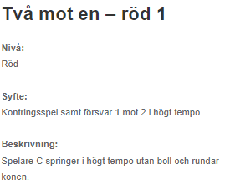 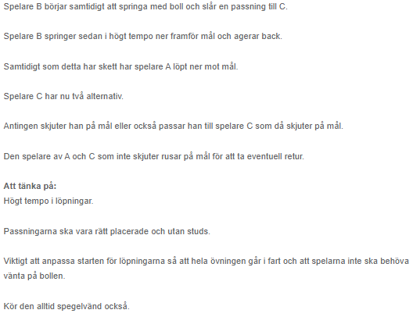

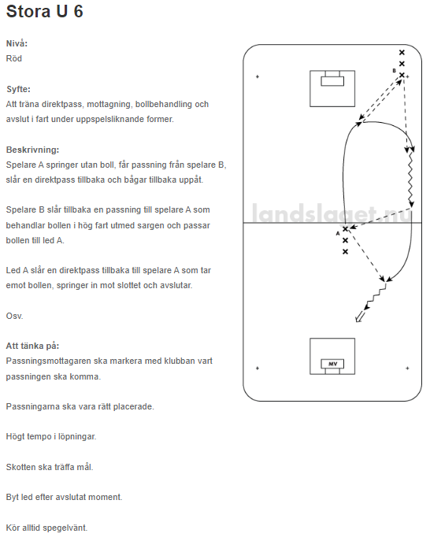

Passning -mottagning I fart

