

Träningsdagbok Sommarträning

Stöcke volleyboll

Säsongen 2021/2022

Lämnas in vid tränings start i höst.

Fyll i så noggrant och samvetsgrant du kan!

Skriv aktuell aktivitet i resp. datumruta och hur lång tid du håller på. Förtydliga gärna med kommentarer till passet i anteckningsrutan.

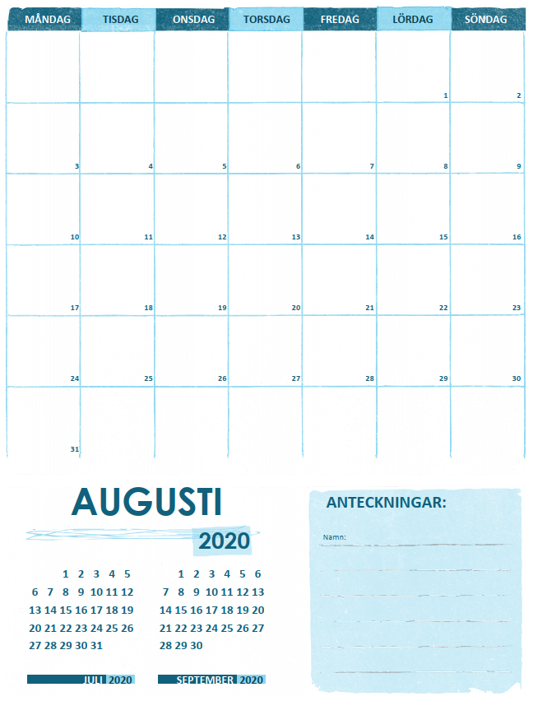

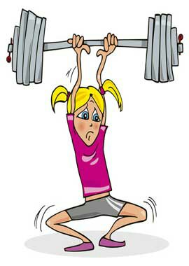

# Juni 2021

|  |  |  |  |  |  |  |
| --- | --- | --- | --- | --- | --- | --- |
| Måndag | Tisdag | Onsdag | Torsdag | Fredag | Lördag | Söndag |
|  | 1 | 2 | 3 | 4 | 5 | 6 |
|  |  |  |  |  |  |  |
| 7 | 8 | 9 | 10 | 11 | 12 | 13 |
|  |  |  |  |  |  |  |
| 14 | 15 | 16 | 17 | 18 | 19 | 20 |
|  |  |  |  |  |  |  |
| 21 | 22 | 23 | 24 | 25 | 26 | 27 |
|  |  |  |  |  |  |  |
| 28 | 29 | 30 |  |  |  |  |
|  |  |  |  |  |  |  |
| Exempel 1  Pass 2 sommarträning  Knäkontroll 1, stretch 10 min | Exempel 2  Beach 1,5 h  Gym ben +bål 30 min | Exempel 3  Kondition löpn. 20 min, rodd intervall 10 min |  |  |  |  |
|  |  |  |  |  |  |  |

## Anteckningar:

Exempel. 1 avstod från löpdelen, cykel 20 min istället.

Exempel 2. Mottag och pass, squats 3 x 12 (70 kg), marklyft 3 x 10(85 kg), frivändning 3 x 8 (30 kg), fällkniv 3 x 30, plankan 3 x 30 s. ______________________________________________________________________________________________________________________________________________________________________________________________________________________________________________________________________________________________________________________________________________________________________________________________________________________________________________________________________________________________________________________________________________________________________________________________________________________________________________________________________________________________________________________________________________________________________________________________________________________________________________________________________________________________________________________________________________________________________________________________________________________________________________________________________________________________________________________________________________________________________________________________________________________________________________________________________________________________________________________________________________________________________________

# Juli 2021

|  |  |  |  |  |  |  |
| --- | --- | --- | --- | --- | --- | --- |
| Måndag | Tisdag | Onsdag | Torsdag | Fredag | Lördag | Söndag |
|  |  |  | 1 | 2 | 3 | 4 |
|  |  |  |  |  |  |  |
| 5 | 6 | 7 | 8 | 9 | 10 | 11 |
|  |  |  |  |  |  |  |
| 12 | 13 | 14 | 15 | 16 | 17 | 18 |
|  |  |  |  |  |  |  |
| 19 | 20 | 21 | 22 | 23 | 24 | 25 |
|  |  |  |  |  |  |  |
| 26 | 27 | 28 | 29 | 30 | 31 |  |
|  |  |  |  |  |  |  |
|  |  |  |  |  |  |  |
|  |  |  |  |  |  |  |

## Anteckningar:

Exempel. 1 avstod från löpdelen, cykel 20 min istället.

Exempel 2. Mottag och pass, squats 3 x 12 (70 kg), marklyft 3 x 10(85 kg), frivändning 3 x 8 (30 kg), fällkniv 3 x 30, plankan 3 x 30 s. ______________________________________________________________________________________________________________________________________________________________________________________________________________________________________________________________________________________________________________________________________________________________________________________________________________________________________________________________________________________________________________________________________________________________________________________________________________________________________________________________________________________________________________________________________________________________________________________________________________________________________________________________________________________________________________________________________________________________________________________________________________________________________________________________________________________________________________________________________________________________________________________________________________________________________________________________________________________________________________________________________________________________________________

## Anteckningar:

______________________________________________________________________________________________________________________________________________________________________________________________________________________________________________________________________________________________________________________________________________________________________________________________________________________________________________________________________________________________________________________________________________________________________________________________________________________________________________________________________________________________________________________________________________________________________________________________________________________________________________________________________________________________________________________________________________________________________________________________________________________________________________________________________________________________________________________________________________________________________________________________________________________________________________________________________________________________________________________________________________________________________________

# Augusti 2021

## Anteckningar:

Exempel. 1 avstod från löpdelen, cykel 20 min istället.

Exempel 2. Mottag och pass, squats 3 x 12 (70 kg), marklyft 3 x 10(85 kg), frivändning 3 x 8 (30 kg), fällkniv 3 x 30, plankan 3 x 30 s. ______________________________________________________________________________________________________________________________________________________________________________________________________________________________________________________________________________________________________________________________________________________________________________________________________________________________________________________________________________________________________________________________________________________________________________________________________________________________________________________________________________________________________________________________________________________________________________________________________________________________________________________________________________________________________________________________________________________________________________________________________________________________________________________________________________________________________________________________________________________________________________________________________________________________________________________________________________________________________________________________________________________________________________

## Anteckningar:

______________________________________________________________________________________________________________________________________________________________________________________________________________________________________________________________________________________________________________________________________________________________________________________________________________________________________________________________________________________________________________________________________________________________________________________________________________________________________________________________________________________________________________________________________________________________________________________________________________________________________________________________________________________________________________________________________________________________________________________________________________________________________________________________________________________________________________________________________________________________________________________________________________________________________________________________________________________________________________________________________________________________________________

|  |  |  |  |  |  |  |
| --- | --- | --- | --- | --- | --- | --- |
| Måndag | Tisdag | Onsdag | Torsdag | Fredag | Lördag | Söndag |
|  |  |  |  |  |  | 1 |
|  |  |  |  |  |  |  |
| 2 | 3 | 4 | 5 | 6 | 7 | 8 |
|  |  |  |  |  |  |  |
| 9 | 10 | 11 | 12 | 13 | 14 | 15 |
|  |  |  |  |  |  |  |
| 16 | 17 | 18 | 19 | 20 | 21 | 22 |
|  |  |  |  |  |  |  |
| 23 | 24 | 25 | 26 | 27 | 28 | 29 |
|  |  |  |  |  |  |  |
| 30 | 31 |  |  |  |  |  |