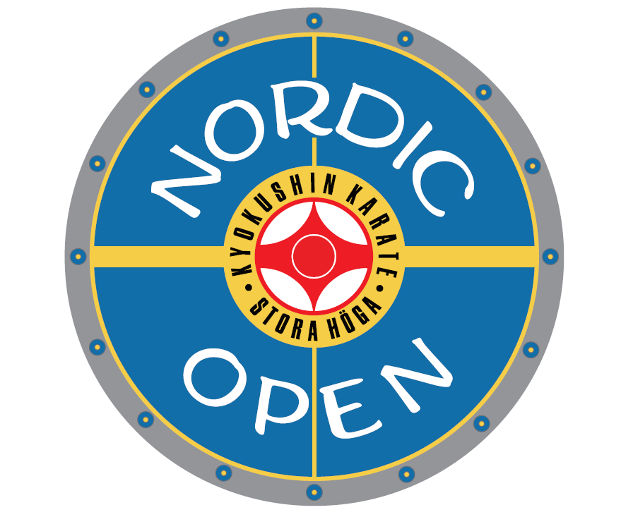

Nordic Open

2023

Nordic Open is an International Kyokushin tournament for children, cadets, juniors, seniors and veterans who participate from various parts of the world. It is open to all Kyokushin groups and organisations which would like to participate and test their skills under the Nordic Open Tournament Regulations.

The competition is not all about winning but is also about meeting other fellow competitors and teams under the traditional Kyokushin values and traditions with respect, curiosity and a strive to always improve oneself in all aspects. Another important goal of the tournament is to allow people, especially young persons, from different places to meet and make new friends and experiences.

The tournament was earlier known as Stora Höga Open. We changed the name to Nordic Open for the 2023 edition.

The rules
You can find the rules for the tournament here here:
Kyokushin tävlingskommittén - Svenska Karateförbundet (swekarate.se)

The rules are in Swedish, if you have any questions, please send a mail to: info@nordicopen.se

Extra Criteria for Swedish competitors (only)
For legal reasons, Swedish competitors (only) from the age of 12 must have a competitor’s card (“Tävlingskort”) issued from an organization under the Swedish Sports Confederation (“Riksidrottsförbundet”) (such as “Budo och Kampsportsförbundet” or “Svenska Karateförbundet”).

Short explanation of the rules for Semi Contact

Scoring Semi contact
If any uncertainties arise about the interpretations of the rules herein, the organization committee has the last word whereby the official rules of Svenska Karateförbundet shall be considered.

Seniors, veterans and 12-17 Years
IPPON is awarded for a technique that prevents the opponent to continue the match within 3 seconds (not full contact to the head), if the other participant is disqualified or if the other party gives up.

WAZA-ARI is awarded for a controlled kick against the head that hits the other participant’s head or helmet and an otherwise allowed technique that prevents the opponent to continue the match momentary. When an opponent is downed with any allowed technique including foot sweeps which are followed up by a well-focused non-contact technique to the body

If equal score: Dominance in strength in combination with technique and number of hits, with correct technique that has hit the opponent.

If any uncertainties arise about the interpretations of the rules herein, the organization committee has the last word whereby the official rules of the Swedish “Karateförbundet” shall be considered.

7-11 Years
Same as above but with no contact against the other opponent’s head/helmet. The kick must stop 5-10 cm from the head and be unblocked.

In the final rounds, a winner always has to be decided.

Allowed techniques:
- all punches to the body
- all kicks to head, except front kicks to the head
- all kicks to the body and legs

Forbidden techniques:
- all punches and blows to head, neck and back
- all kicks to any part of the knee, crotch and back
- front kick to the head (jodan mae geri, jodan yoko geri, jodan ushiro geri)
- knee kicks towards the head (jodan hiza geri)
- kagato otoshi, uchiro mawashi geri to the head
- punching or kicking the opponent while lying on the floor
- Failing to obey the referee’s instructions during the bout, or making comments to the referee
- leaving the tatami on different occasions during the fight
- producing indecent, disrespectful and aggressive behaviour
- grabbing and pulling
- Any other techniques or practice that the referee of the contest shall decide is improper or unfair

Categories
The categories below can change depending on the number and actual weight of the participants in each group. All groups under 18 years old is fighting under semi contact rules.

Female
7 year -30, +30
8 - 9 year -38, -46, +46
10 - 11 year -35, -43, -51, +51
12 - 13 year -45, -55, +55
14 – 15 year -50, -60, +60
16 – 17 year -55, -65, +65
U21
Full contact: - 55, -65, +65
Seniors
Semi contact: -55, -65, +65
Full contact: -55, -65, +65
Veterans
Semi contact -65, +65

Male
7 year -30, +30
8 - 9 year -38, -46, +46
10 - 11 year -35, -43, -51, +51
12 - 13 year -45, -55, -65, +65
14 – 15 year -50, -60, -70, +70
16 – 17 year -55, -65, -75, +75
U21
Full contact: 70, -80, +80
Seniors
Semi contact: -70, -80, +80
Full contact: -70, -80, +80
Veterans
Semi contact -80, +80

Match time:
7-13 year - 1.30 + 1 min
14-17 years - 2 + 1 min
No weight for the competitors under 18, it will be a decision after the last extension.

Seniors and Veterans, Semi Contact - 2 + 2 (weight) + 2 min
U21 Full Contact: 2 + 2 (weight) + 2 min
Seniors Full Contact - 3 + 2 (weight) + 2 min

Weight difference
Men: 5 kg (+80 kg is 10 kg)
Women: 4 kg (+65 kg is 8 kg)

However, the Tournament organising committee reserves the right to decide the match length in the tournament. Factors for this includes, but is not limited to, the number of participants, number of tatamis, availability of referees and total competition schedule.

In the classes under 18 years with 3 competitors, it will be Round Robin.
In case of equal, the following parameters will decide the placement:
Most Ippon (total)
Most Waza-ari (total)
Least Genten (total)
Least Chui (total)
Least Absolute weight

Please note: The semi contact divisions for the Seniors are for beginners. If you have competed in more than three full contact tournaments, you must register in the full contact division.
The Veteran classes is open to all from 40 years of age and above.

Protection
In the above divisions, there are four protection categories:
1. Participants 7 - 13 years
From 7 years up and including 13 years, the participants must wear fist protection, mouth protection, helmet, shin guard and a body protector. No breast cups allowed under the body protector and men must wear crotch guard, crotch guard for females are optional.

2. Participants 14 - 17 years
From 14 years up and including 17 years, the participants must wear fist protection, mouth protection, helmet and shin guard. Females must wear breast cups and men must wear crotch guard, crotch guard for females are optional.

3. Participants Seniors and Veterans semi contact
Seniors and Veterans, from 18 and up, must wear fist protection, mouth protection, and shin guard. Females must wear breast cups and men must wear crotch guard, crotch guard for females are optional.

4. Participants Seniors full contact
Seniors, from 18 and up must wear mouth protection. Females must wear breast cups and men must wear crotch guard, crotch guard for females are optional.

See you in Nordic Open

OSU!!

