Domarschema Ungdom Vår 2025 på Hammarvallen
(Uppdaterat 250427)

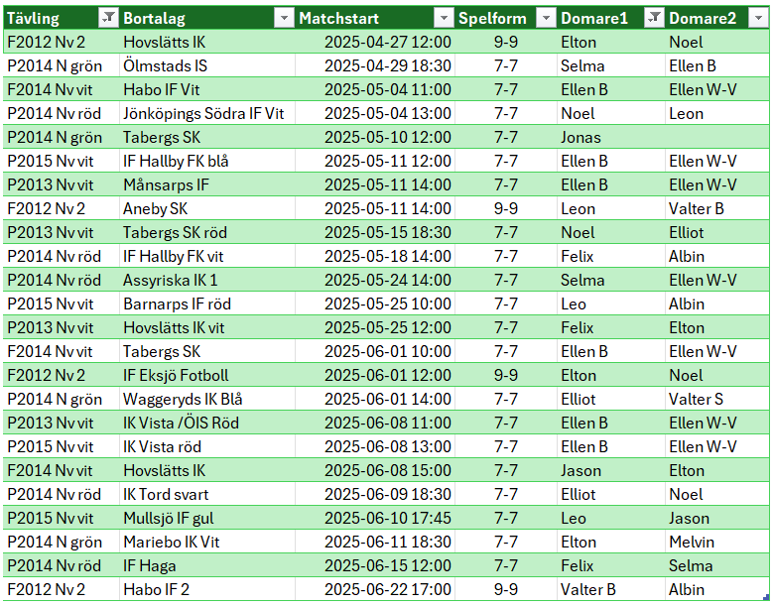

Kontaktuppgifter Ungdomsdomare Hammarvallen
(Uppdaterat 250427)

Domare | Nummer | Spelform
Ellen Borst | 0702-850733 | 3-3 5-5 7-7 9-9
Ellen Wetter Viscovich | 0735-326532 | 3-3 5-5 7-7 9-9
Selma Kjellerstedt | 0702-534792 | 3-3 5-5 7-7 9-9
Albin Pellgaard | 0793-130694 | 3-3 5-5 7-7 9-9
Elton Rosenkvist | 0705-585911 | 3-3 5-5 7-7 9-9
Elliott Rosenkvist | 0705-585928 | 3-3 5-5 7-7 9-9
Felix Johansson | 0702-027714 | 3-3 5-5 7-7 9-9
Leon Lindén | 0728-582822 | 3-3 5-5 7-7 9-9
Noel Öggesjö | 0731-188110 | 3-3 5-5 7-7 9-9
Valter Borgmark | 0703-601442 | 3-3 5-5 7-7 9-9
Jason Tingrud | 0733-880392 | 3-3 5-5 7-7
Leo Jakovic |  | 3-3 5-5 7-7
Melvin Öggesjö |  | 3-3 5-5 7-7
Jonas Tingrud | 0700-423367 | 3-3 5-5 7-7 9-9 11-11
Martin Mammoo | 0704-492293 | 3-3 5-5 7-7 9-9 11-11

