
LILLPITE IF
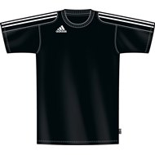
T-SHIRT
130:-
……………………………………………………………………………………………………………………
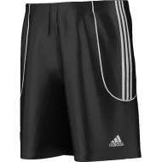
SHORTS
130:-
………………………………………………………………………………………………
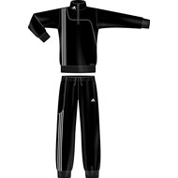
MJUKISOVERALL (NY!)
JR : 350:-
SR :390:-
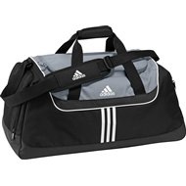
…………………………………………………………………………………………………………………
VÄSKA
200:-
………………………………………………………………………………………………………………………
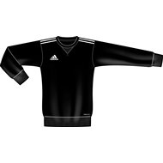
SWEAT TOP
200:-
……………………………………………………………………………………………………………………….
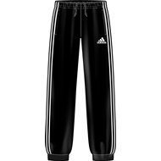
SWEAT PANT
250:-
………………………………………………………………………………………………………………………
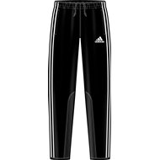
TRÄNINGSBYXA
TIRO TRG PANT
JR: 250:-
SR:290:
……………………………………………………………………………………………………………………….
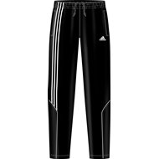
TRÄNINGSBYXA
(SERENO TRG PANT)
200:-

VINDOVERALL

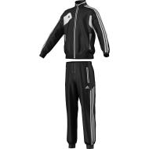
JR : 550:-
SR : 590:-

