Inbjudan
Vänskapsmatch mellan Kärra P15 and RCD Espanyol de Barcelona
Var: Klarebergsvallen 7-manna, se karta nedan. Eller LINK
När: 1230-1600, 11 Nov 2023

Övrigt:
Regler enligt 5mot5 utan sarg. LINK Fair Play. LINK
Speltid 2x10min.
6 lag, 4 matcher var
Domare kommer finnas på plats.

Spelschema:
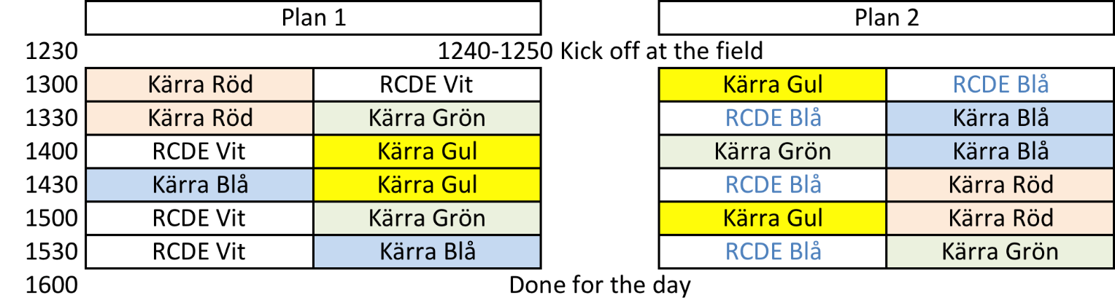
Plan nummer/plats & Parkeringsplatser:
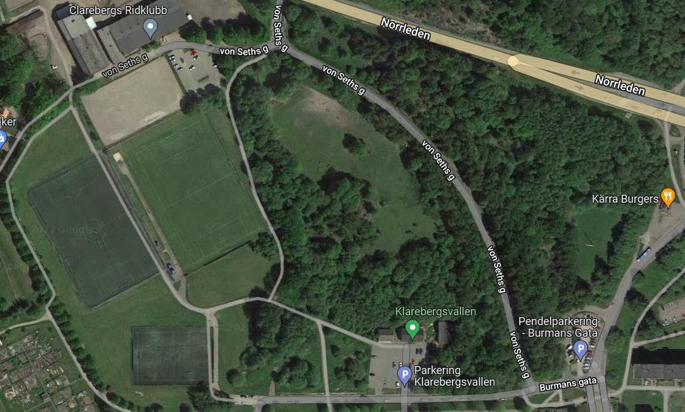
Mat/fika
Toalett/ombyte/vatten
2
1

P

P
Röd = parkering

Invitation
Friendly training game between Kärra P15 and RCD Espanyol de Barcelona
Where: Klarebergsvallen 7-manna, see map below. Or LINK
When: 1230-1600, 11 Nov 2023

Other info:
Rules according to 5vs5 with lines. LINK Fair Play. LINK
Play time 2x10min.
6 teams, 4 matches each
Referee will be on location.

Day schedule:
Field numbers/location, facilities & parking overview:
Toilet/chan-ging/water
Food/fika
2
1

P

P
Red = parking.

