GIF 1

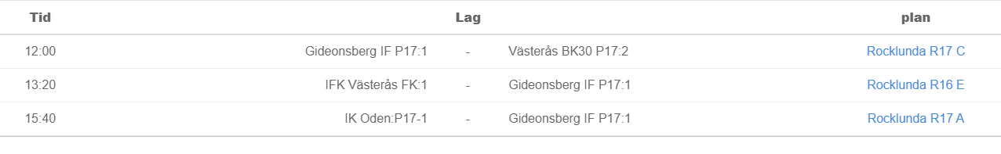

GIF 2

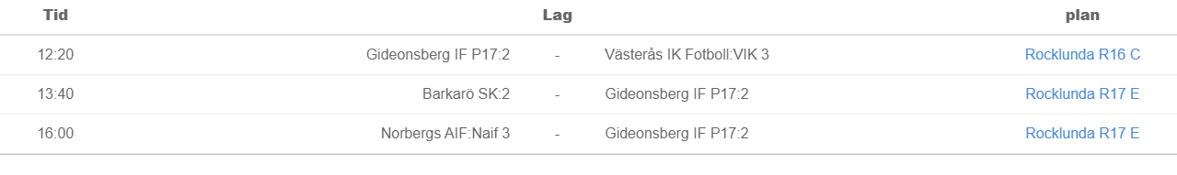

GIF 3

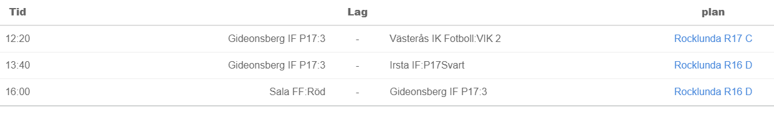

GIF 4

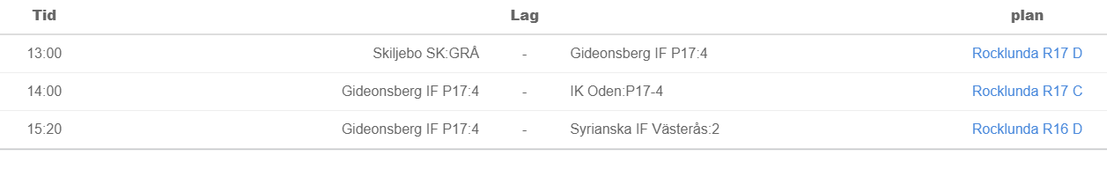

GIF 5

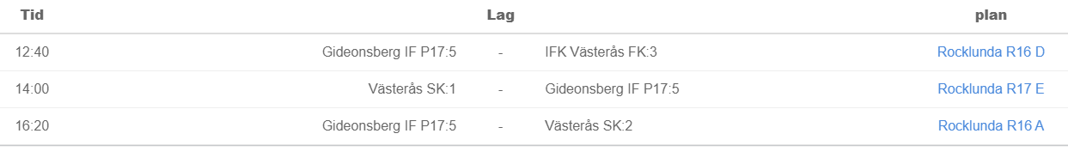

**Fotbollens dag:**

GIF 1:

Matchtider: 12:00, 13:20, 15:40

**Mia & Madde**

Elias, Milton, Medin, Josua, Filip, Olle

GIF 2:

Matchtider: 12:20, 13:40, 16:00

**Ary & Ola**

Aaron, Dewin, Theodor, Samir, Sven, Leandro, Elis T

GIF 3:

Matchtider: 12:20, 13:40, 16:00

**Jani & Daniel**

Ebbe, Kean, Salem, Frank Widerrönn, Malte, Edvin

GIF 4:

Matchtider: 13:00, 14:00, 15:20

**Johan W**

Alexander, Tage, Frank Wang, Valter, Hugo S, Milan

GIF 5:

Matchtider: 12:40, 14:00, 16:20

**Rebaz & Johan F-L**

Arman, Viggo, Vide, Noel, Liam, Munir

