Flamesshopen

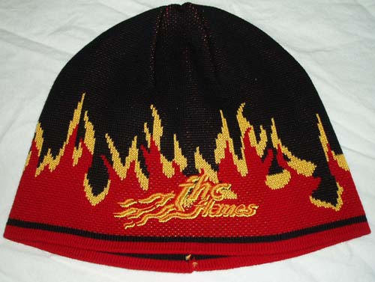 | 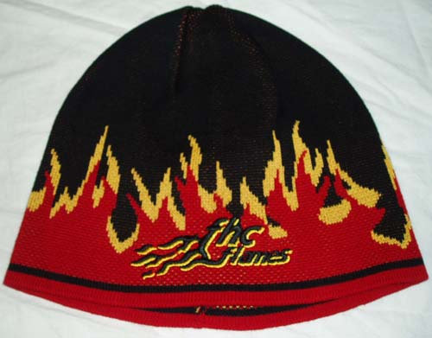
Mössa 110 kr | Mössa 110 kr

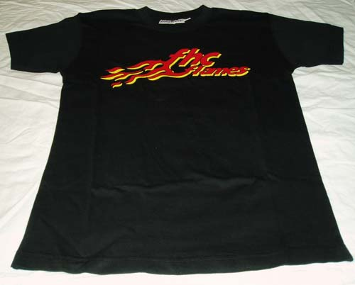 | 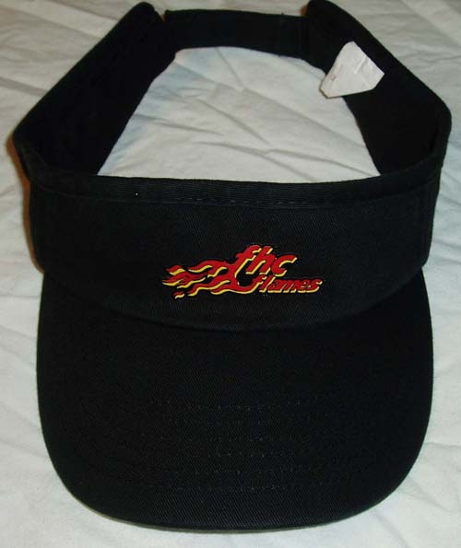
T-shirt 80 kr | Skärmkeps 50 kr

