 24 rullar Toapapper 12 rullar Hushåll Säljare:

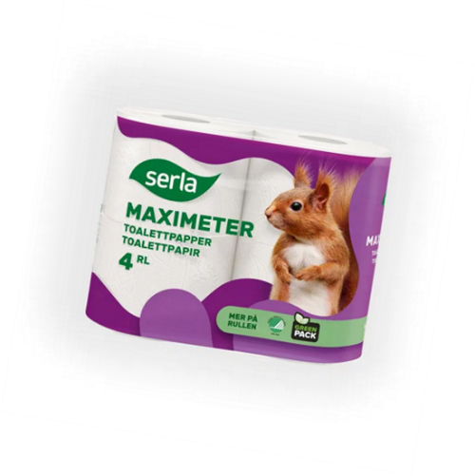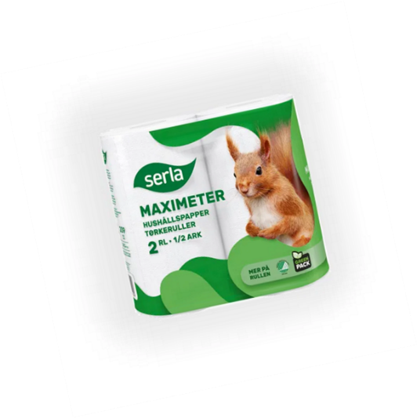 **Pris: 270 kr**  **Pris: 260 kr**

Sista beställningsdag 21 sep

Leverans under v 40, 2024

Betalning sker vid leverans.

|  |  |  |  |  |  |  |
| --- | --- | --- | --- | --- | --- | --- |
| **Namn:** | **Adress:** | **Ort:** | **Telefon** | **Antal Toa** | **Antal Hushåll** | Betalt |
|  |  |  |  |  |  |  |
|  |  |  |  |  |  |  |
|  |  |  |  |  |  |  |
|  |  |  |  |  |  |  |
|  |  |  |  |  |  |  |
|  |  |  |  |  |  |  |
|  |  |  |  |  |  |  |
|  |  |  |  |  |  |  |
|  |  |  |  |  |  |  |
|  |  |  |  |  |  |  |
|  |  |  |  |  |  |  |
|  |  |  |  |  |  |  |