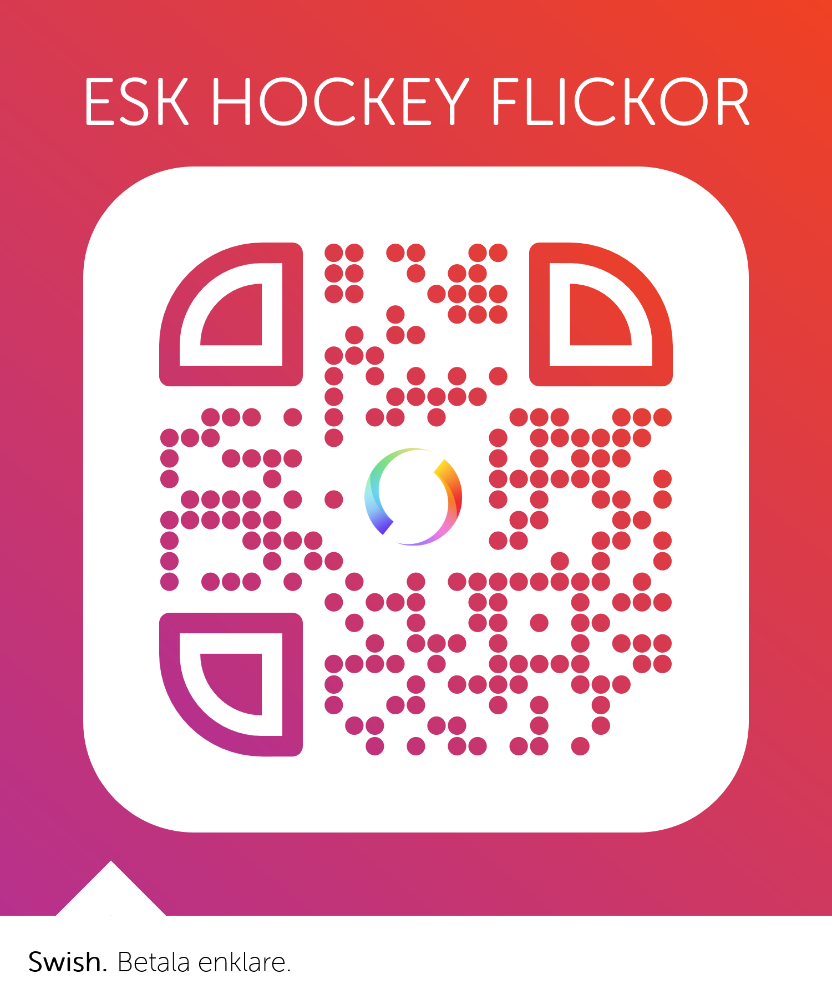ESK HOCKEY

TEAM FLICKOR

SWISH

123-449 60 89