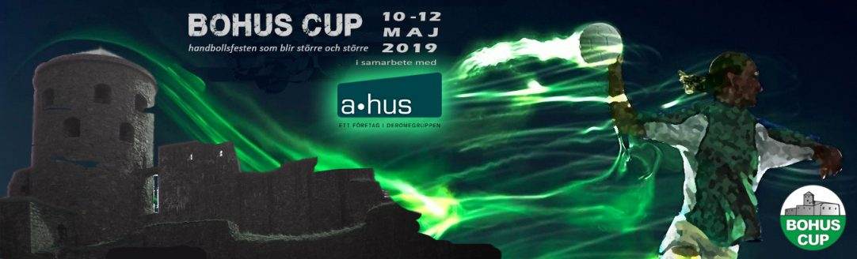

Café under Bohus Cup
Lördagen den 11/5
Tid | Bemanna | Barn | Föräldrar | Telefon
10:30-13:30 | Café | Ana Marij Dragas | Bozica Tomeska, Dragan Dragas | 0704-010175, 0737-199454
10:30-13:30 | Café | Ella Bramstång | Gunilla Hansson, Marcus Bramstång | 0739-150074, 0705-670644
10:30-13:30 | Café | Emilia Ling | Rasmus Ling, Martina Lundin | 0704327904, 0737618789
10:30-13:30 | Café | Emina Osmanovic | Jasmina Osmanovic, Mehidin Osmanovic | 0733505621, 0704419638
10:30-13:30 | Café | Lanya Abdulrahman | Sami Abdulrahman, Sherin Shuwan | 0736330370, 0735867255
10:30-13:30 | Grill | Felicia Almqvist | Marina Almqvist, Hossein Maljov | 076-1907375, 070-7787085
10:30-13:30 | Grill | Hana Vejselovic | Dzemal Vejselovic, Fahreta Vejselovic | 0704977069, 0737457110
10:30-13:30 | Grill | Medina Jakupovic | Emir Jakupovic, Aldina Jakupovic | 0730689897, 0700768836
10:30-13:30 | Matchklocka | Hanna Radoncic | Lejla Radoncic, Sanel Radoncic | 0765531418, 0739024018
10:30-13:30 | Matchklocka | Linnea Rosell | Anneli Rosell, Johan Rosell | 0766210571, 0729774424
10:30-13:30 | Resurs | Isabella Lo Truglio | Förnamn Lo Truglio, Saverio Lo Truglio | 0726558748, 0761616748
10:30-13:30 | Resurs | Rebecka Jankulovska | Diana Jankulovska, Simonovska | 0736-26 35 48

