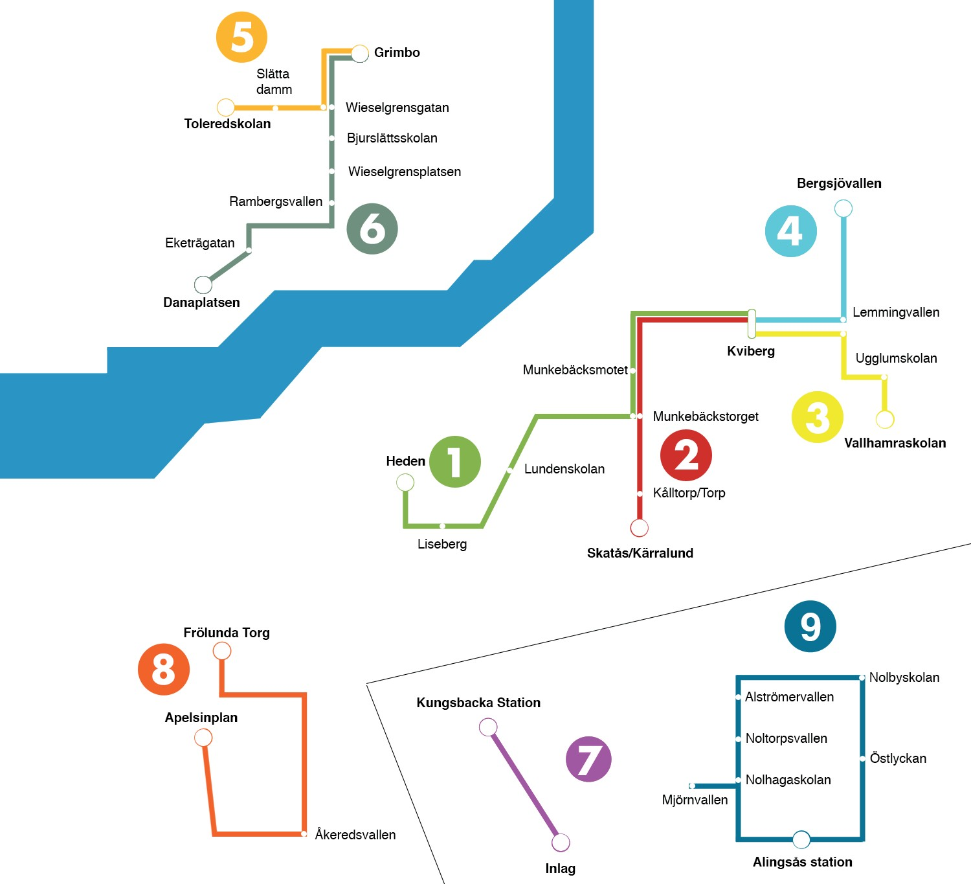Gothia Line

GOTHIA LINE 1 Heden – Kviberg (Mon-Fri)
Heden Liseberg Lunden Munkebäcksto. Munkebäcksmot. Kviberg Center Mon-Tue 07.45 + 4 min + 7 min + 12 min no stop + 25 min
Wed 06.45 + 4 min + 7 min + 12 min no stop + 25 min
Thu-Fri 06.45 + 4 min + 7 min + 12 min +15 min + 28 min The bus runs every 30 min. Last departure 18.15 (Mon-Tue), 21.15 (Wed-Fri)
GOTHIA LINE 1 Kviberg – Heden (Mon – Fri)
Kviberg Lemmingva. Munkebäcksmot. Munkebäckstor. Lunden Liseberg Heden Mon-Tue 07.15 + 2 min no stop + 7 min + 13 min + 16 min + 25 min
Wed 06.15 + 2 min no stop + 7 min + 13 min + 16 min + 25 min
Thu-Fri 06.15 + 2 min + 7 min + 10 min + 16 min + 19 min + 28 min The bus runs every 30 min. Last departure 18.45 (Mon-Tue), 21.45 (Wed-Fri)
GOTHIA LINE 2 Skatås - Kviberg (Mon-Thu)
Skatås Torp Munkebäckstorget Kviberg Center Mon-Tue 07.45 + 3 min +6 min + 15 min
Wed-Thu 06.45 + 3 min +6 min + 15 min
The bus runs every 30 min. Last departure 18.15 (Mon-Tue), 21.15 (Wed-Thu)
GOTHIA LINE 2 Kviberg - Skatås (Mon-Thu)
Kviberg Center Lemmingvallen Munkebäckstorget Torp Skatås Mon-Tue 07.30 + 2 min + 8 min + 12 min +15 min
Wed-Thu 06.30 + 2 min + 8 min + 12 min +15 min
The bus runs every 30 min. Last departure 18.30 (Mon-Tue), 21.30 (Wed-Thu)
GOTHIA LINE 3 Vallhamra Torg - Kviberg (Mon-Fri)
Vallhamra Torg Ugglumskolan Lemmingvallen Kviberg Center Mon-Tue 07.30 + 4 + 8 +15
Wed-Fri 06.30 + 4 + 8 +15
The bus runs every 30 min. Last departure 18.00 (Mon-Tue), 21.00 (Wed-Fri)
GOTHIA LINE 3 Kviberg - Vallhamra Torg (Mon-Fri)
Kviberg Center Lemmingvallen Ugglumskolan Vallhamra Torg Mon-Tue 08.00 + 3 min +10 min +12
Wed-Fri 07.00 + 3 min +10 min +12
The bus runs every 30 min. Last departure 18.30 (Mon-Tue), 21.30 (Wed-Fri)
GOTHIA LINE 4 Kviberg - Bergsjövallen (Mon-Thu)
Kviberg Center Lemmingvallen Kortedalavallen Bergsjövallen Mon-Tue 07.45 + 3 min + 8 min + 13 min
Wed-Thu 06.45 + 3 min + 8 min + 13 min The bus runs every 30 min. Last departure 18.15 (Mon-Tue), 20.15 (Wed, Thu)
GOTHIA LINE 4 Bergsjövallen - Kviberg (Mon-Thu)
Bergsjövallen Kortedalavallen Lemmingvallen Kviberg Center Mon-Tue 08.00 + 5 min + 10 min + 15 min
Wed-Thu 07.00 + 5 min + 10 min + 15 min The bus runs every 30 min. Last departure 18.30 (Mon-Tue), 20.30 (Wed, Thu)
GOTHIA LINE 5 Toleredskolan-Grimbo (Mon-Thu)
Toleredsskolan Slättadamm Wieselgrensg Grimbo Mon-Thu 06.30 + 2 min + 6 min + 9 min
The bus runs every 30 min. Last departure 18.00 (Mon), 19.00 (Tue), 20.30 (Wed), 21.30 (Thu)
GOTHIA LINE 5 Grimbo-Toleredskolan (Mon-Thu)
Grimbo Wieselgrensg. Slättadamm Toleredsskolan Mon-Thu 07.00 + 3 min + 7 min + 9 min
The bus runs every 30 min. Last departure 18.30 (Mon), 19.30 (Tue), 21.00 (Wed), 22.00 (Thu)
GOTHIA LINE 6 Danapl.-Grimbo (Mon-Thu)
Danapl. Eketräg. Rambergsv. Wieselgr.pl. Bjurslättssk. Wieselgrensg. Grimbo Mon-Thu 06.25 +5 min +8 min +10 min +12 min +13 min +16min
The bus runs every 30 min. Last departure 17.55 (Mon), 18.55 (Tue), 20.25 (Wed), 21.25 (Thu)
GOTHIA LINE 6 Grimbo-Danapl. (Mon-Thu)
Grimbo Wieselgrensg. Bjurslättssk. Wieselgr.pl. Rambergsv. Eketräg. Danapl. Mon-Thu 07.00 +3 min +4 min +6 min +8 min +11 min +16 min
The bus runs every 30 min. Last departure 18.30 (Mon), 19.30 (Tue), 21.00 (Wed), 22.00 (Thu)

GOTHIA LINE 7 Kungsbacka Stn. - Inlag - Kungsb.Stn.(Mon-Thu)
The bus runs in connection with the train schedule as long at the games are playing.The bus takes 5
min. Starts 8.00 (Mon, Tue), 7.00 (Wed, Thu)
GOTHIA LINE 8 Frölunda Torg - Apelsinplan (Mon-Thu)
Frölunda Torg Åkeredsvallen Apelsinplan Mon-Thu 06.30 + 14 min + 25 min

The bus runs every 30 min. Last departure 18.30 (Mon,Tue), 19.00 (Wed), 20.30 (Thu)
GOTHIA LINE 8 Apelsinplan - Frölunda Torg (Mon-Thu)
Apelsinplan Åkeredsvallen Frölunda Torg Mon-Thu 07.00 + 13 min + 21 min
The bus runs every 30 min. Last departure 19.00 (Mon,Tue), 19.30 (Wed), 21.00 (Thu)
GOTHIA LINE 9 Alingsås (Mon-Fri)
Station Östlyckan Nolby Alströmer Noltorpsva. Nolhagask. Mjörnva. Station Mon-Thu 06.30 + 3 min +6min +9 min +11 min +16 min +21 min +30 min
Fri 06.30 + 3 min +6min +9 min no stop +16 min no stop +30 min The bus runs every 15 min (Fri 30 min).
Last departure 18.30 (Mon), 19.00 (Tue), 21.30 (Wed), 20.00 (Thu, Fri)

KVIBERG SHUTTLE Kviberg 7 - Kviberg 25 (Mon-Fri)
The bus runs every 20 min as long as there are games.
TRAIN Centralstationen - Kungsbacka Station
Centralstationen Liseberg Mölndals stn. Kungsbacka stn.
06.45 + 4 min + 8 min 07.10
The train runs every 30 min.
TRAIN Kungsbacka Station – Centralstationen
Kungsbacka stn. Mölndals stn. Liseberg Centralstationen 06.15 + 15 min + 19 min 06.40
The train runs every 30 min.

